ASSIGNMENT 1
AI ASSISTED CODING 2303A52443
Siddhartha

Task 1: AI-Generated Logic Without Modularization (Fibonacci Sequence Without Functions)

Scenario
You are asked to write a quick numerical sequence generator for a learning platform prototype.

Task Description
Use GitHub Copilot to generate a Python program that:
  - Prints the Fibonacci sequence up to n terms
  - Accepts user input for n
  - Implements the logic directly in the main code
  - Does not use any user-defined functions

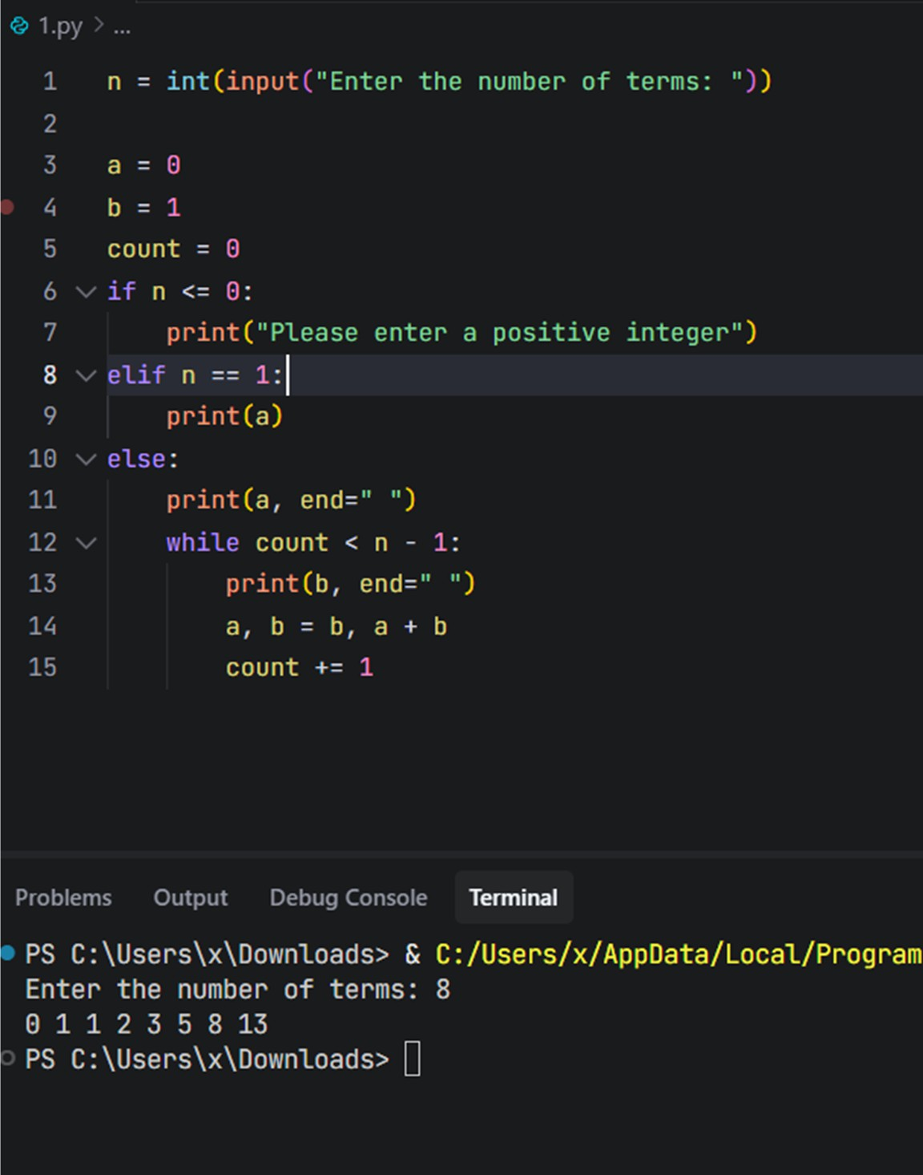

Task 2: AI Code Optimization & Cleanup (Improving Efficiency)

Scenario
The prototype will be shared with other developers and needs optimization.

Task Description
  - Examine the Copilot-generated code from Task 1 and improve it by:
  - Removing redundant variables
  - Simplifying loop logic
  - Avoiding unnecessary computations
  - Use Copilot prompts such as:
    - “Optimize this Fibonacci code”
    - “Simplify variable usage”

IMPROVED CODE
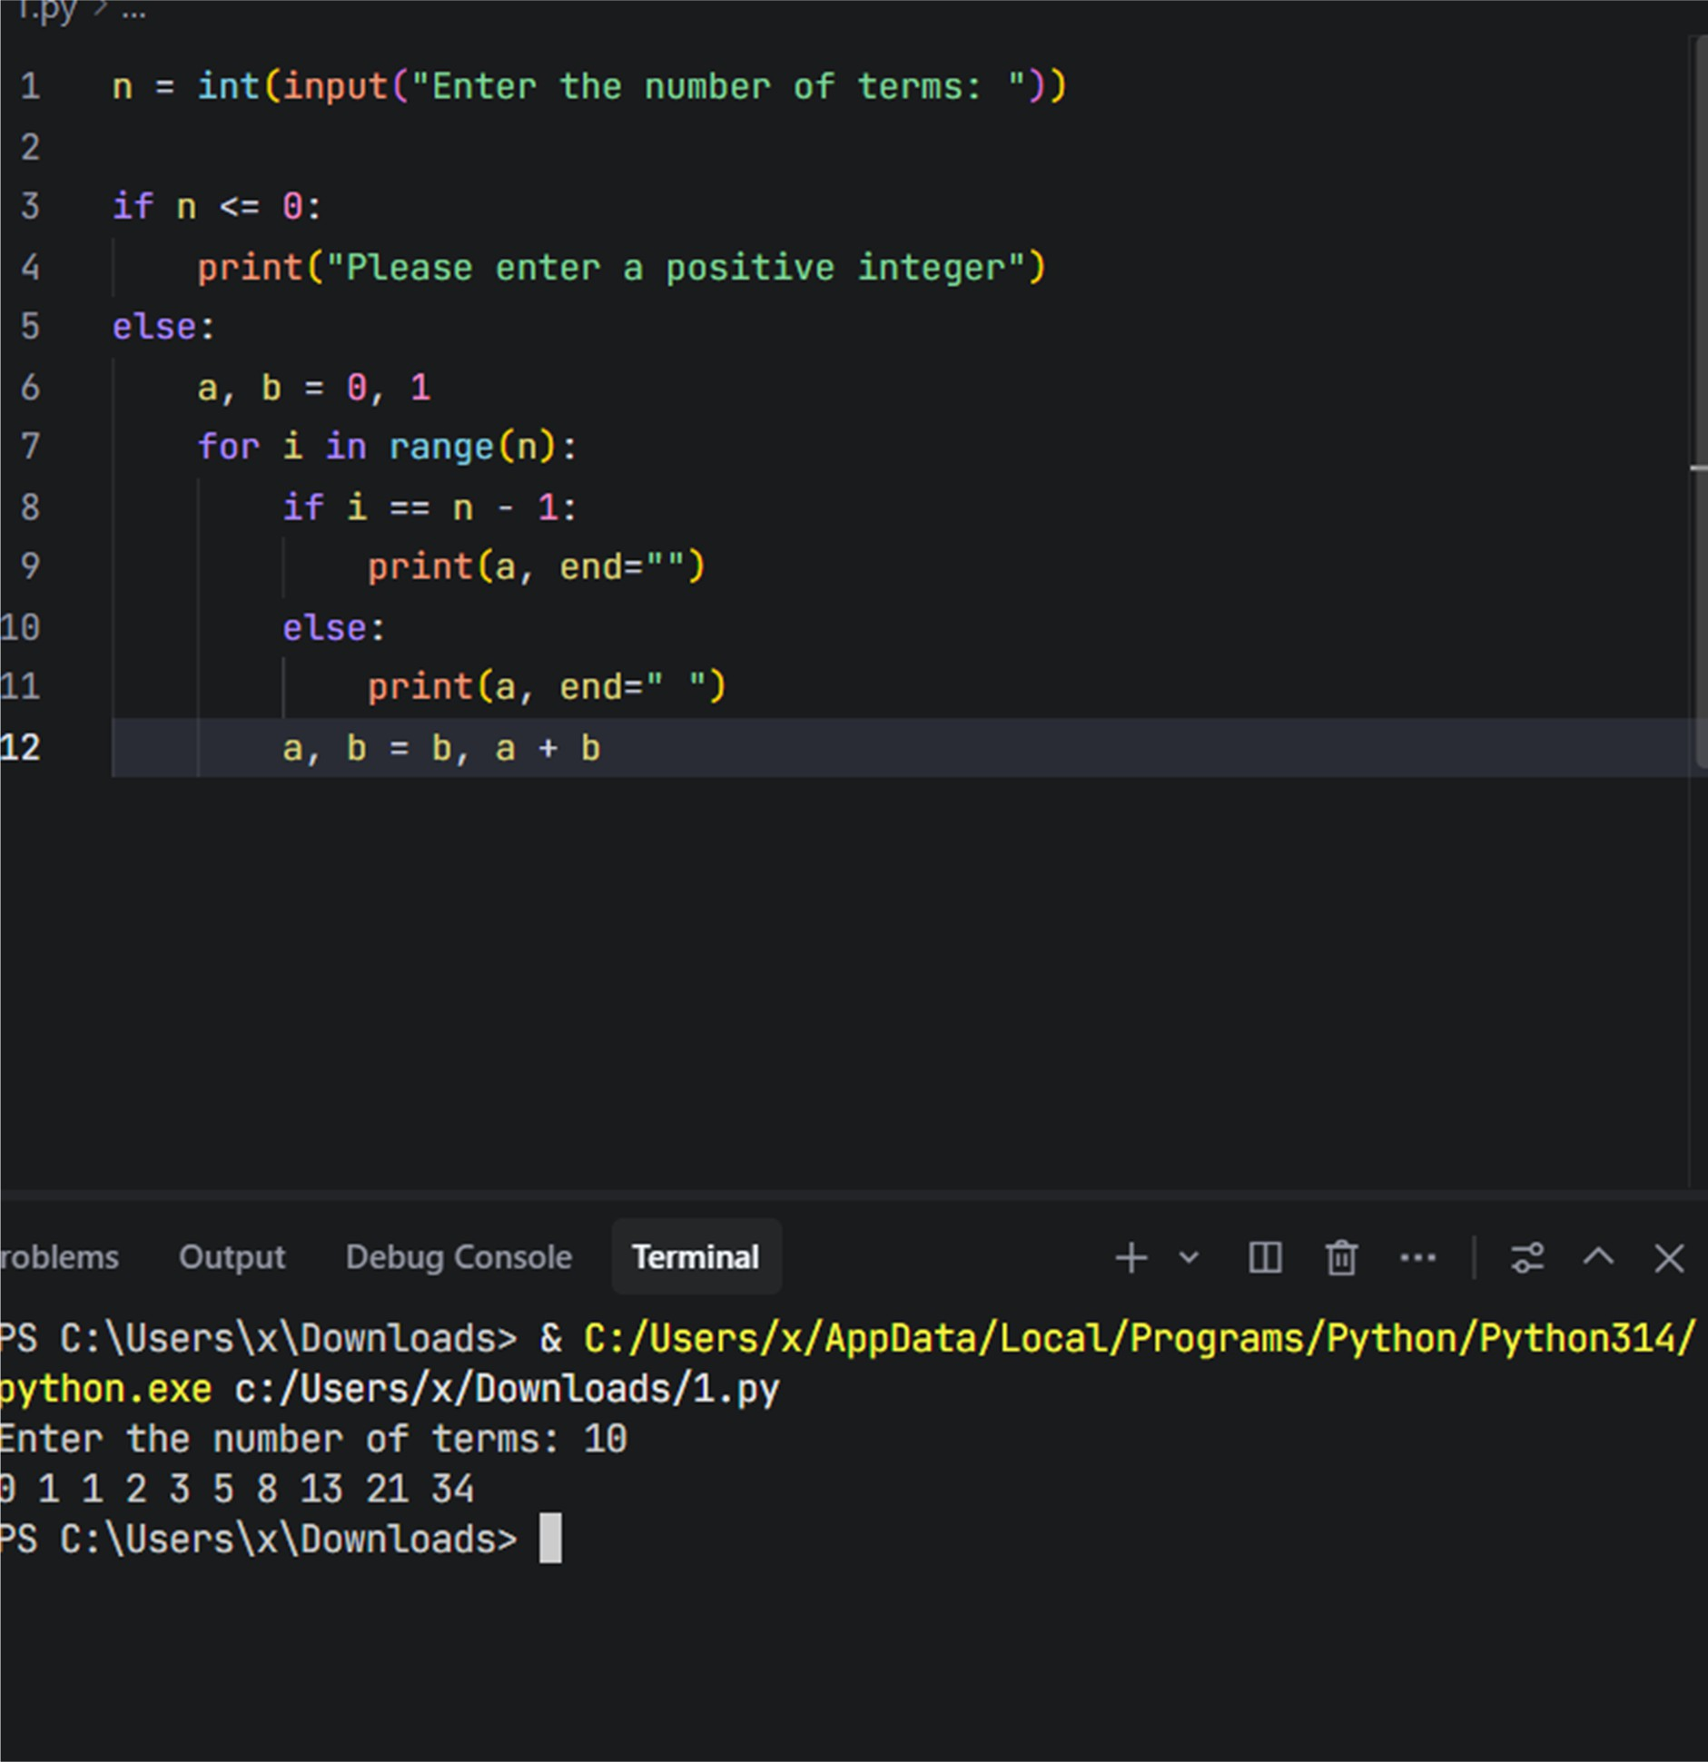

EXPLANATION
This version keeps everything in the main code (no functions) but:

- Removes the extra count variable
- Uses a for loop directly over the number of terms
- Avoids a separate n == 1 branch
- Uses a single print location for all terms What was inefficient / less clean in the original

- Redundant loop counter

  - count was tracking iterations, but Python already gives you loop counters with range .
  - Managing count manually ( count = 0 , count += 1 ) adds noise.
- Unnecessary branching for n == 1

  - Special-case branch elif n == 1: printed a alone.
  - Then for larger n, the code printed a once before the loop and b inside the loop.
  - Logic is split across multiple places, which reduces readability.
- Two separate print patterns

  - First term ( a ) is printed before the loop.
  - Remaining terms ( b ) are printed inside the loop.
  - This makes it harder to reason about “what exactly is printed each iteration”.
- Less direct mapping to “print n Fibonacci numbers”

  - The condition while count < n - 1 is slightly less intuitive than “repeat n times”.

Task 3: Modular Design Using AI Assistance (Fibonacci Using Functions)

Scenario
The Fibonacci logic is now required in multiple modules of an application.

Task Description
Use GitHub Copilot to generate a function-based Python program that:
  - Uses a user-defined function to generate Fibonacci numbers
  - Returns or prints the sequence up to n
  - Includes meaningful comments (AI-assisted)

Expected Output
  - Correct function-based Fibonacci implementation
  - Screenshots documenting Copilot’s function generation

Sample test cases with outputs
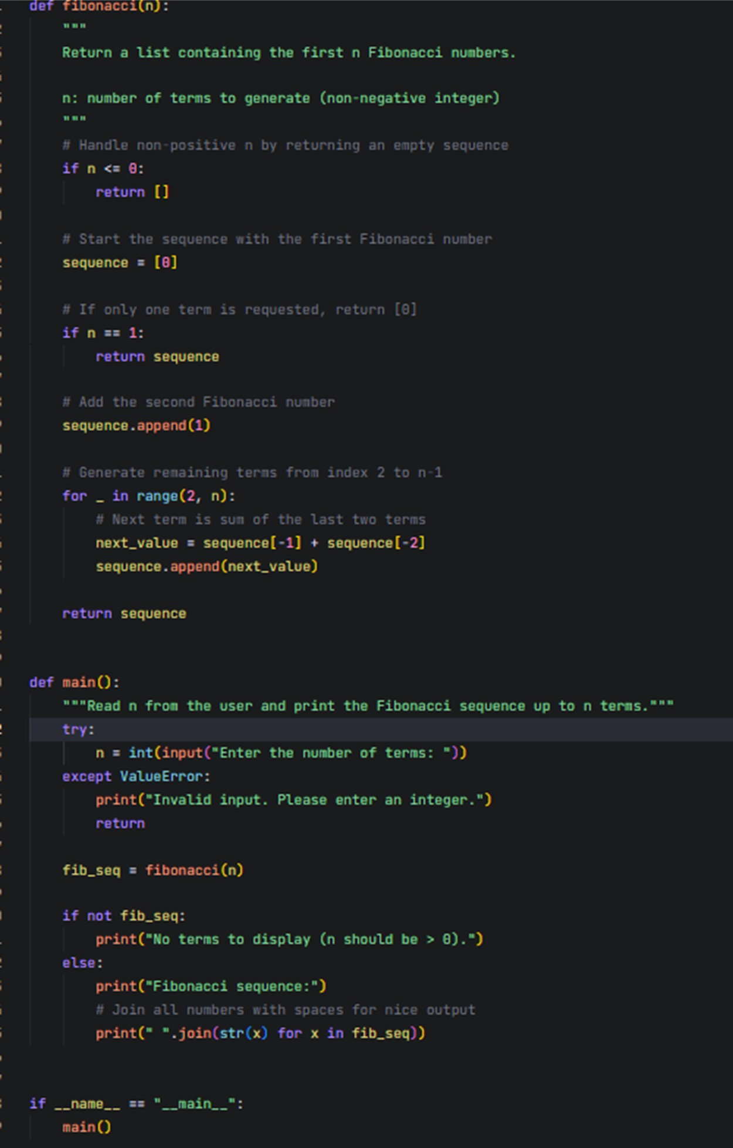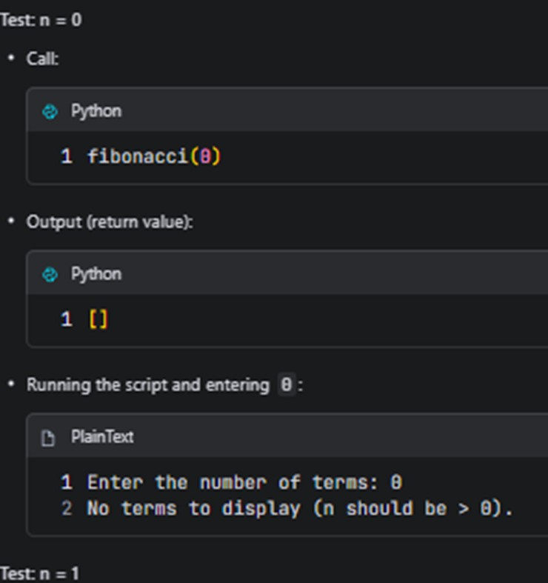

Task 4: Comparative Analysis – Procedural vs Modular Fibonacci Code

Scenario
You are participating in a code review session.

Task Description
Compare the Copilot-generated Fibonacci programs:
  - Without functions (Task 1)
  - With functions (Task 3)
  - Analyze them in terms of:
    - Code clarity
    - Reusability
    - Debugging ease
    - Suitability for larger systems

Comparison Overview

- Procedural version (Task 1) : all logic in main , no functions
- Modular version (Task 3) : fibonacci(n) function + main() wrapper
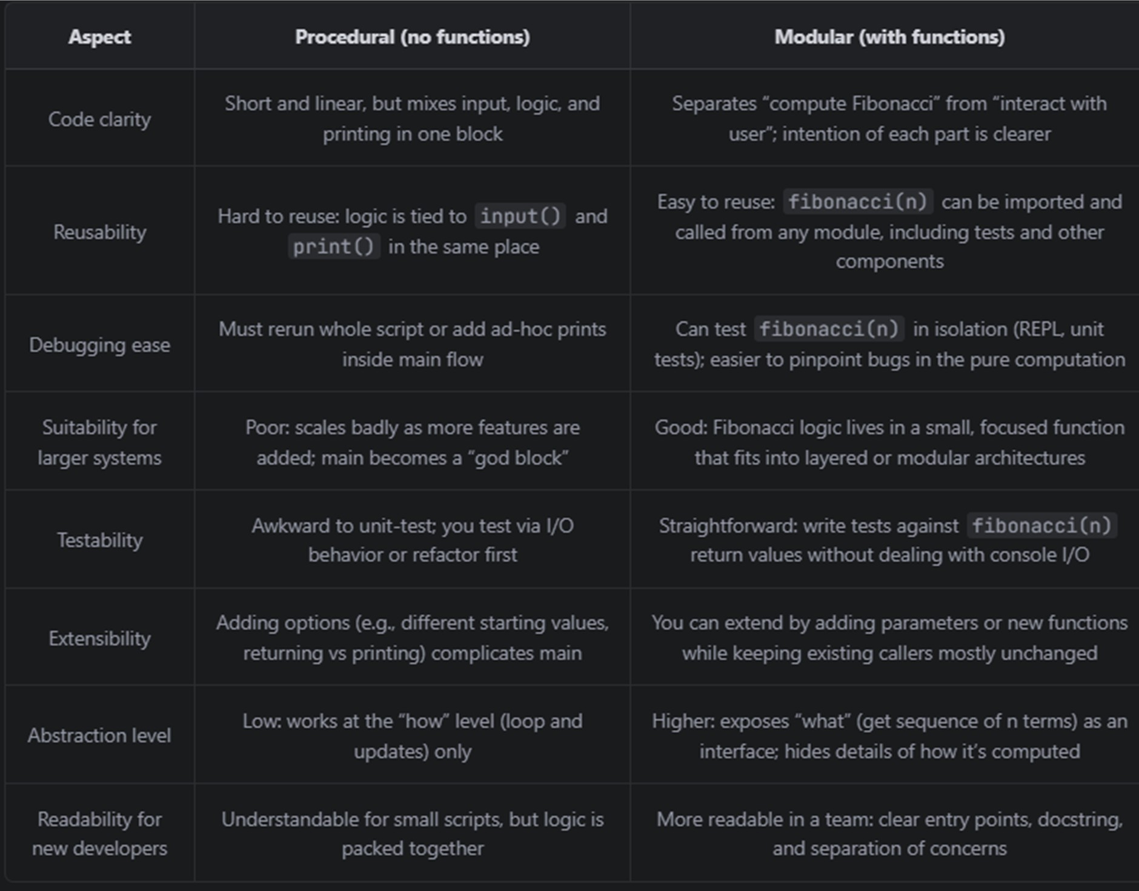

Short Analytical Report

- Code clarity

  - The procedural version is fine for very small, one-off scripts: everything is visible in one place.
  - However, it mixes three concerns: reading input, computing Fibonacci, and printing results. As soon as you add more features (validation, logging, different output formats), this block gets harder to read.
  - The modular version clearly separates concerns:
    - fibonacci(n) is about the sequence calculation.
    - main() is about user interaction and display.
  - This makes it easier for a reviewer to answer “where is the Fibonacci logic?” and “where is the I/O?”.
- Reusability

  - In the procedural version, the only way to “reuse” the logic is to copy and paste the loop, or to call the script as a separate process. Both are fragile.
  - The modular version provides a reusable unit: fibonacci(n) can be imported by other modules ( from fib import fibonacci ) and used in GUI apps, APIs, other scripts, or tests.
- Debugging ease

  - Debugging the procedural code often means sprinkling extra prints into the main block or stepping through the entire input/print flow in a debugger.
  - With the function-based design, you can:
    - Call fibonacci(5) directly in a REPL and inspect the list.
    - Add unit tests for edge cases ( n = 0 , n = 1 , large n ) without touching I/O.
  - When a bug appears, you can quickly determine whether it lives in the pure logic ( fibonacci ) or in the user interaction ( main ).
- Suitability for larger systems

  - Larger applications benefit from modularity: clear APIs, small functions, and layers (UI, business logic, data).
  - The procedural version doesn’t scale well because as more requirements are added, the main block grows and becomes tightly coupled to everything else.
  - The modular version maps naturally into a larger architecture:
    - fibonacci(n) is part of a “domain” or “core” module.
      - Different front-ends (CLI, web, GUI) can all reuse the same core function.

Task 5: AI-Generated Iterative vs Recursive Fibonacci Approaches (Different Algorithmic Approaches for Fibonacci Series)

Scenario
Your mentor wants to assess AI’s understanding of different algorithmic paradigms.

Task Description
Prompt GitHub Copilot to generate:
An iterative Fibonacci implementation A recursive Fibonacci implementation

ITERATIVE
def fib_iterative(n):
if n < 0:
raise ValueError("n must be non-negative")

a, b = 0, 1
for _ in range(n):
a, b = b, a + b return a

RECURSIVE
def fib_recursive(n):
if n < 0:
raise ValueError("n must be non-negative")

if n == 0:
return 0 if n == 1:
return 1

return fib_recursive(n - 1) + fib_recursive(n - 2)

Execution flow

- Iterative

  - Initialize a = 0 , b = 1 .
  - Loop n times:
    - Set (a, b) to the next Fibonacci pair (b, a + b) .
  - After the loop, a holds fib(n) .
  - Control flow is straightforward: one loop, no call stack growth.
- Recursive

  - For each call fib_recursive(n) :
    - If n is 0 or 1, return the base value directly.
    - Otherwise, call itself twice:
      - fib_recursive(n - 1)
      - fib_recursive(n - 2)
    - Sum the two results.
  - The call tree branches until all paths hit n == 0 or n == 1 .

Complexity and performance comparison

- Time complexity

  - Iterative:
    - Each loop iteration does O(1) work.
    - Loop runs n times.
    - Time complexity: O(n) .
  - Naive recursive:
    - Each call branches into two more calls (except at base cases).
    - Number of calls grows roughly like 2^n .
    - Time complexity: O(2^n) (exponential).
- Space complexity

  - Iterative:
    - Uses a constant number of variables ( a , b , loop index).
    - Space complexity: O(1) auxiliary space.
  - Naive recursive:
    - Each call waits on the result of two child calls.
    - Maximum recursion depth is n (for the longest path down to 0/1).
    - Space complexity: O(n) due to call stack.
- Performance for large n

  - Iterative:
    - Scales well up to very large n (e.g., hundreds of thousands) until integers or time become the bottleneck.
    - Work grows linearly; practical for most uses.
  - Naive recursive:
    - Becomes unusable quickly:
      - For n ~ 30–40 , it is already noticeably slow.
      - For n > 40–45 , runtime explodes because of exponential growth in calls.

when recursion should be avoided

- You need to handle large n .
- You are in a performance-sensitive path (e.g., called many times in a loop or server endpoint).
- The recursive formulation introduces overlapping subproblems (like Fibonacci), causing repeated work and exponential behavior.
- Your runtime has a strict recursion depth limit that the algorithm might hit.

